### [**Bunny Hexagon Box**](https://papercraftetc.blogspot.com/2015/02/the-bunny-hexagon-box-is-ideal-way-to.html)

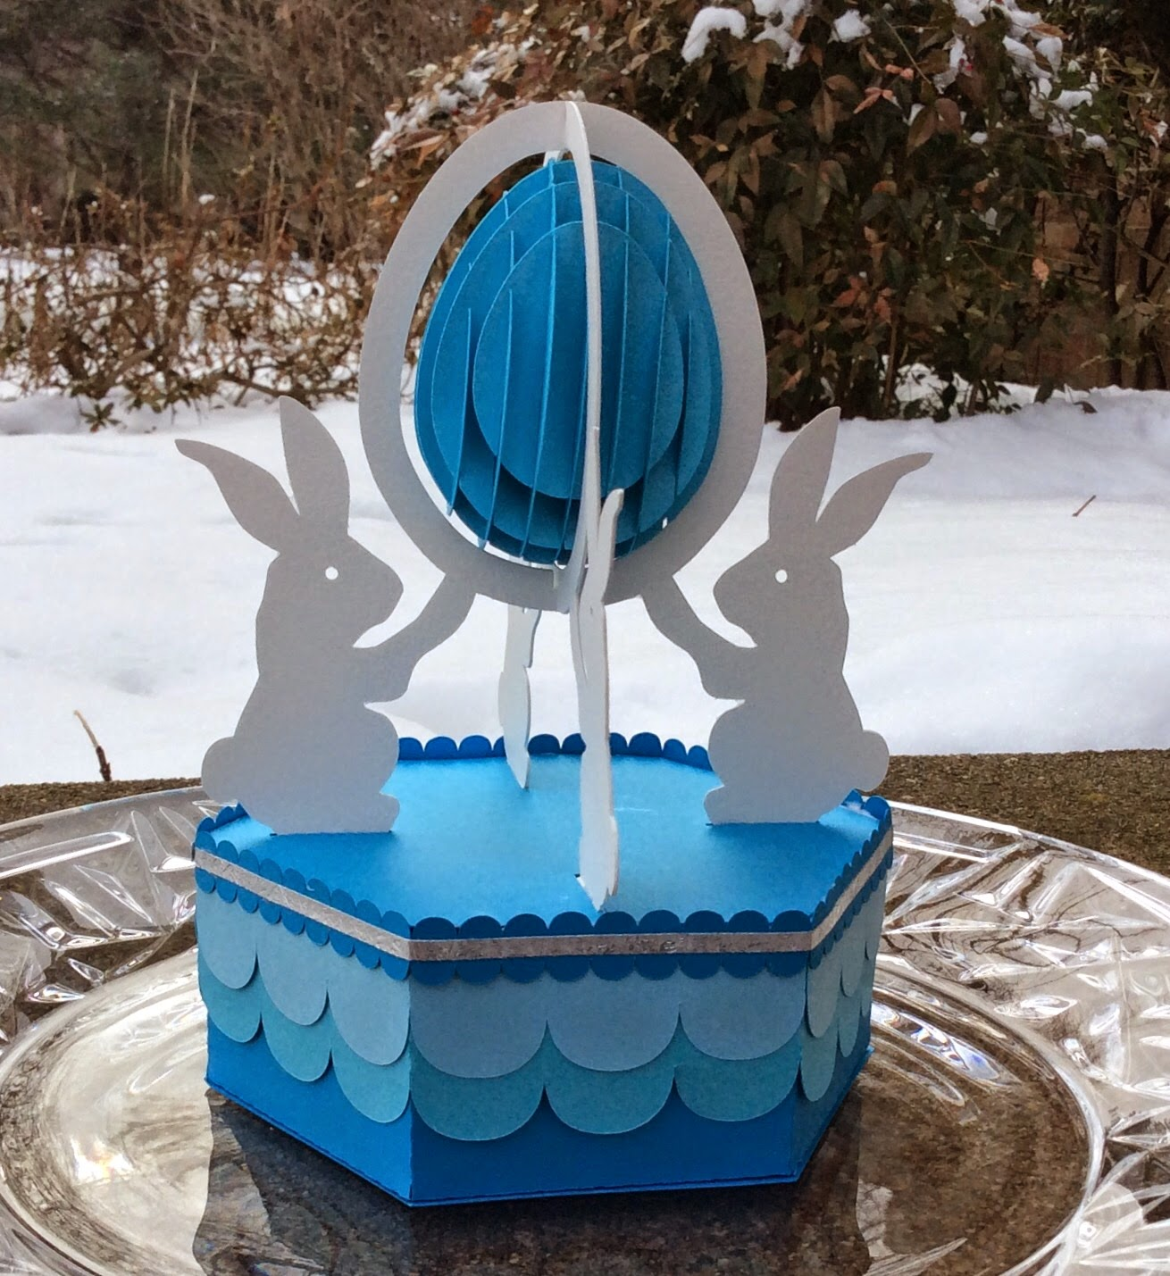

The Bunny Hexagon box is an ideal way to display a sliceform egg.

I used cardstock for everything except the bunny which I used watercolor paper. I cut two sets of bunnies in watercolor paper (I glued them together to create a double thickness) in order to ensure a sturdy base.

Slide the egg pieces together as shown below.

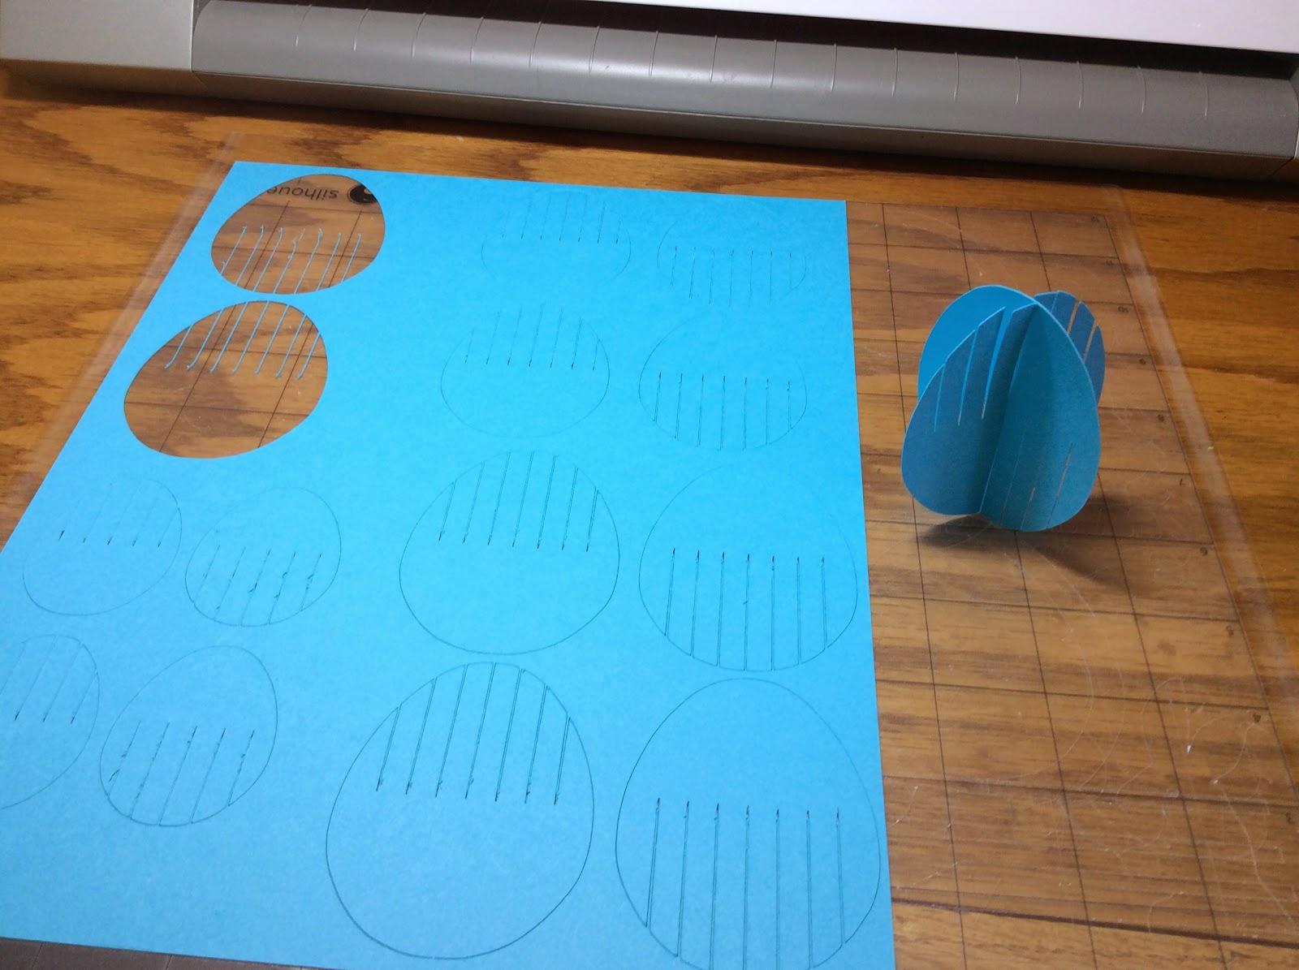

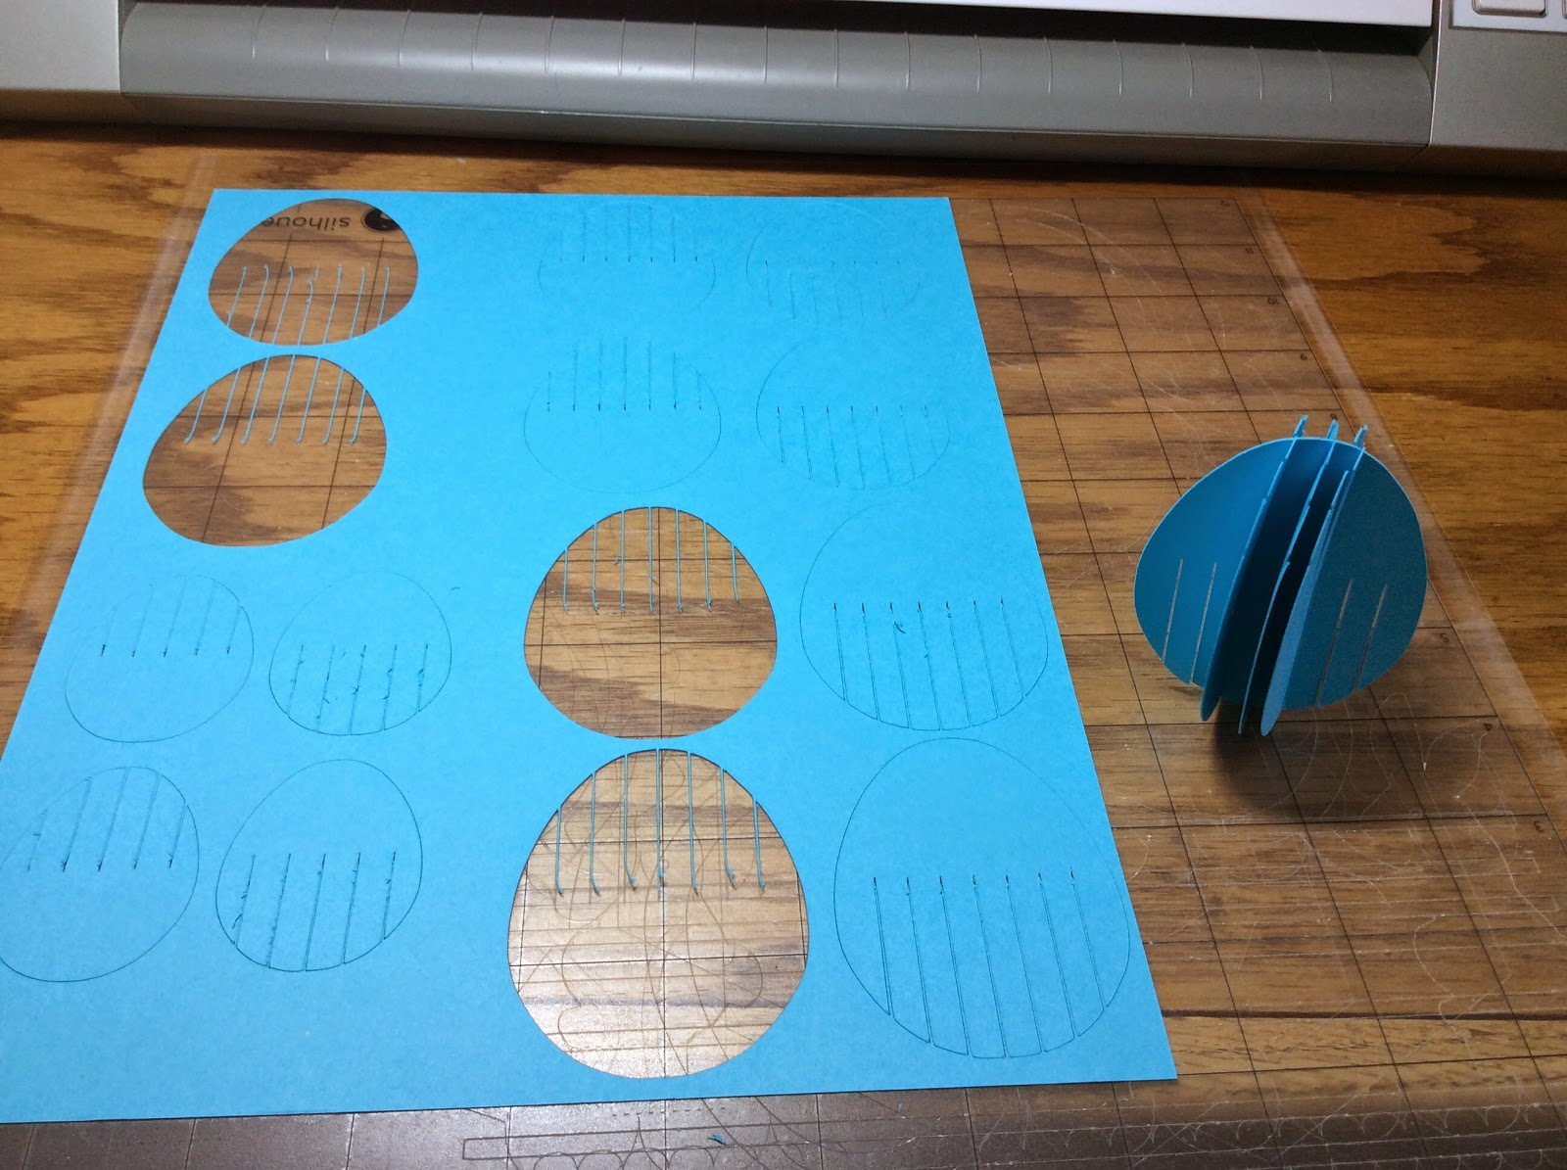

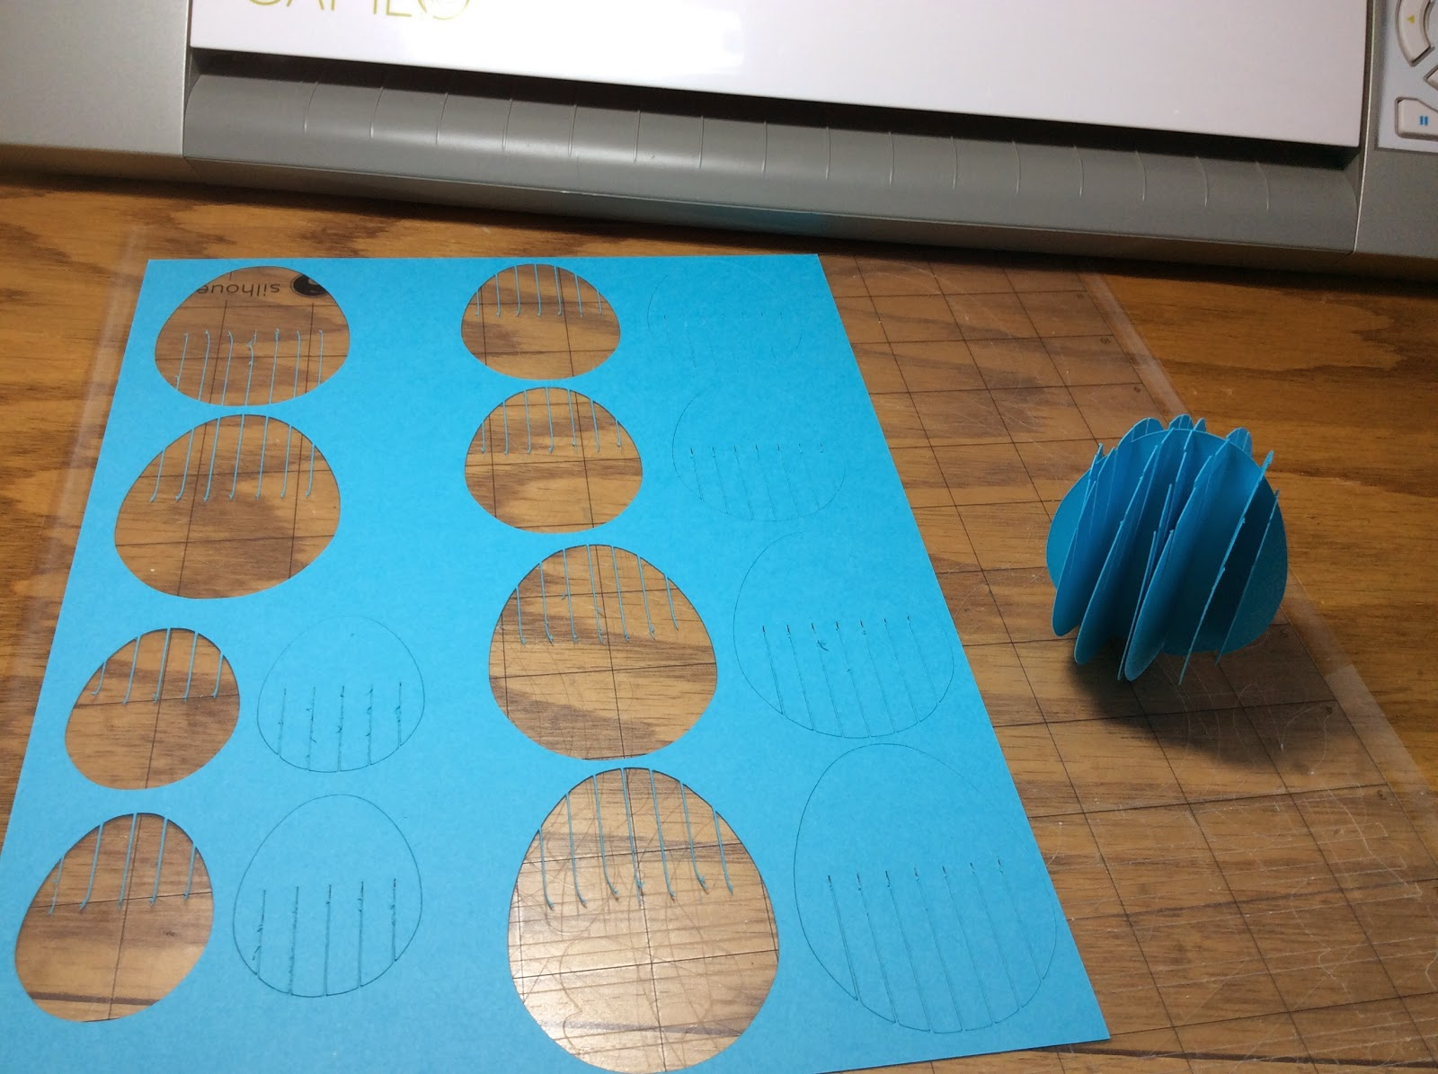

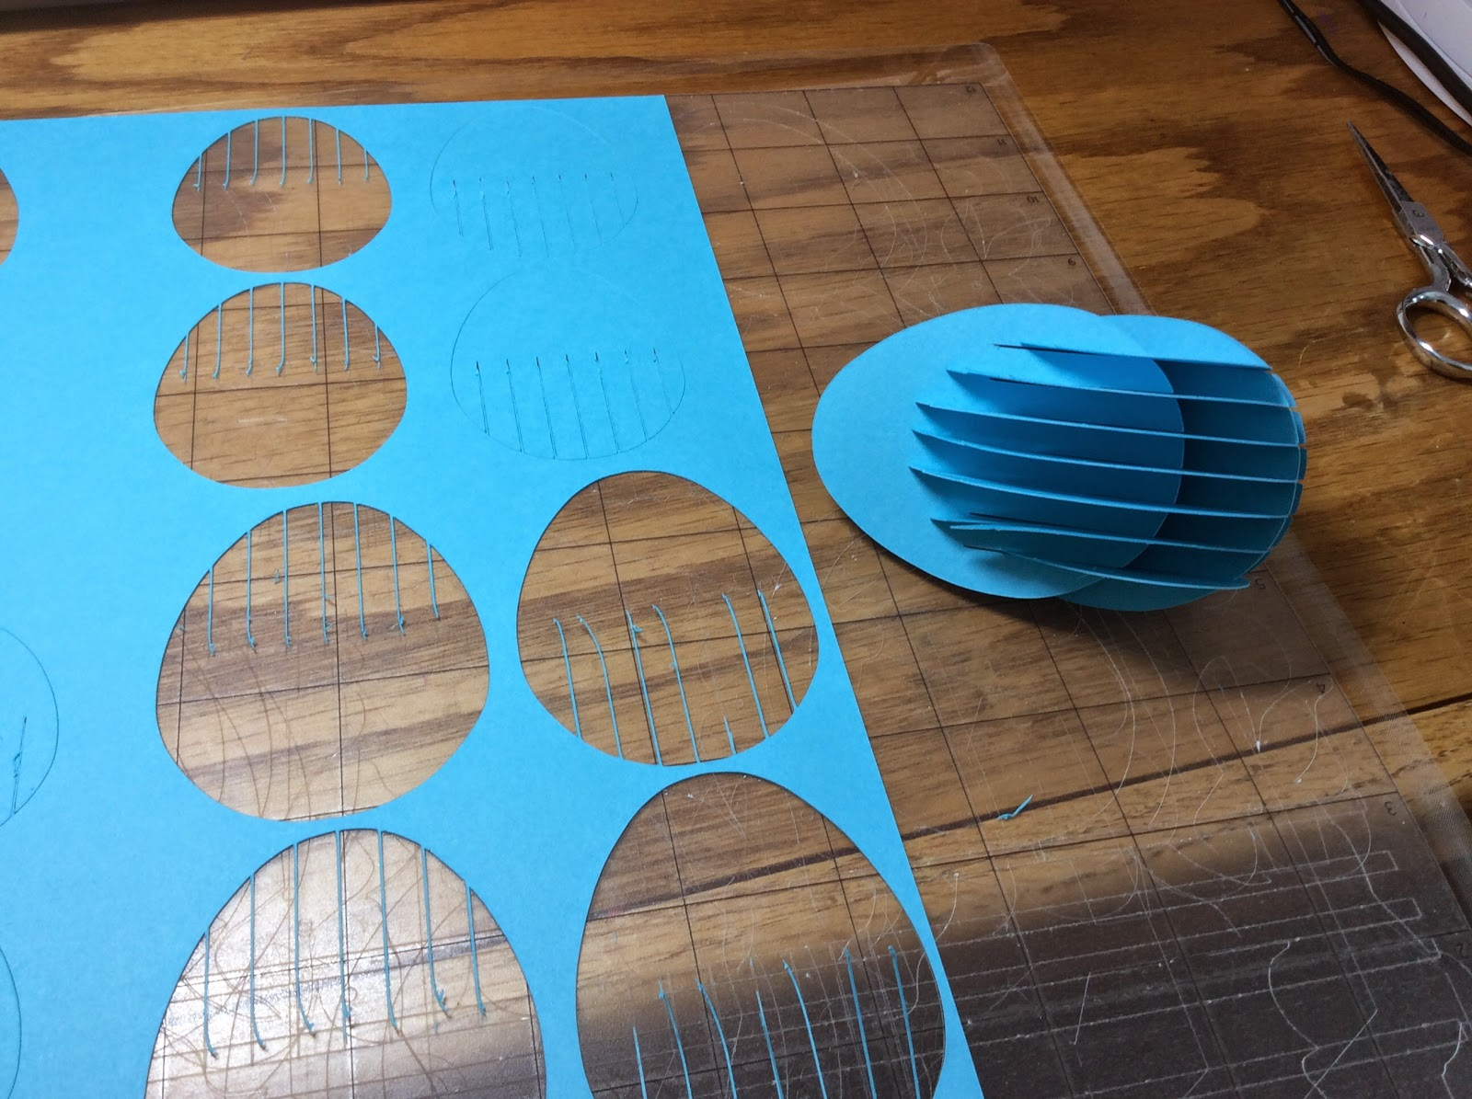

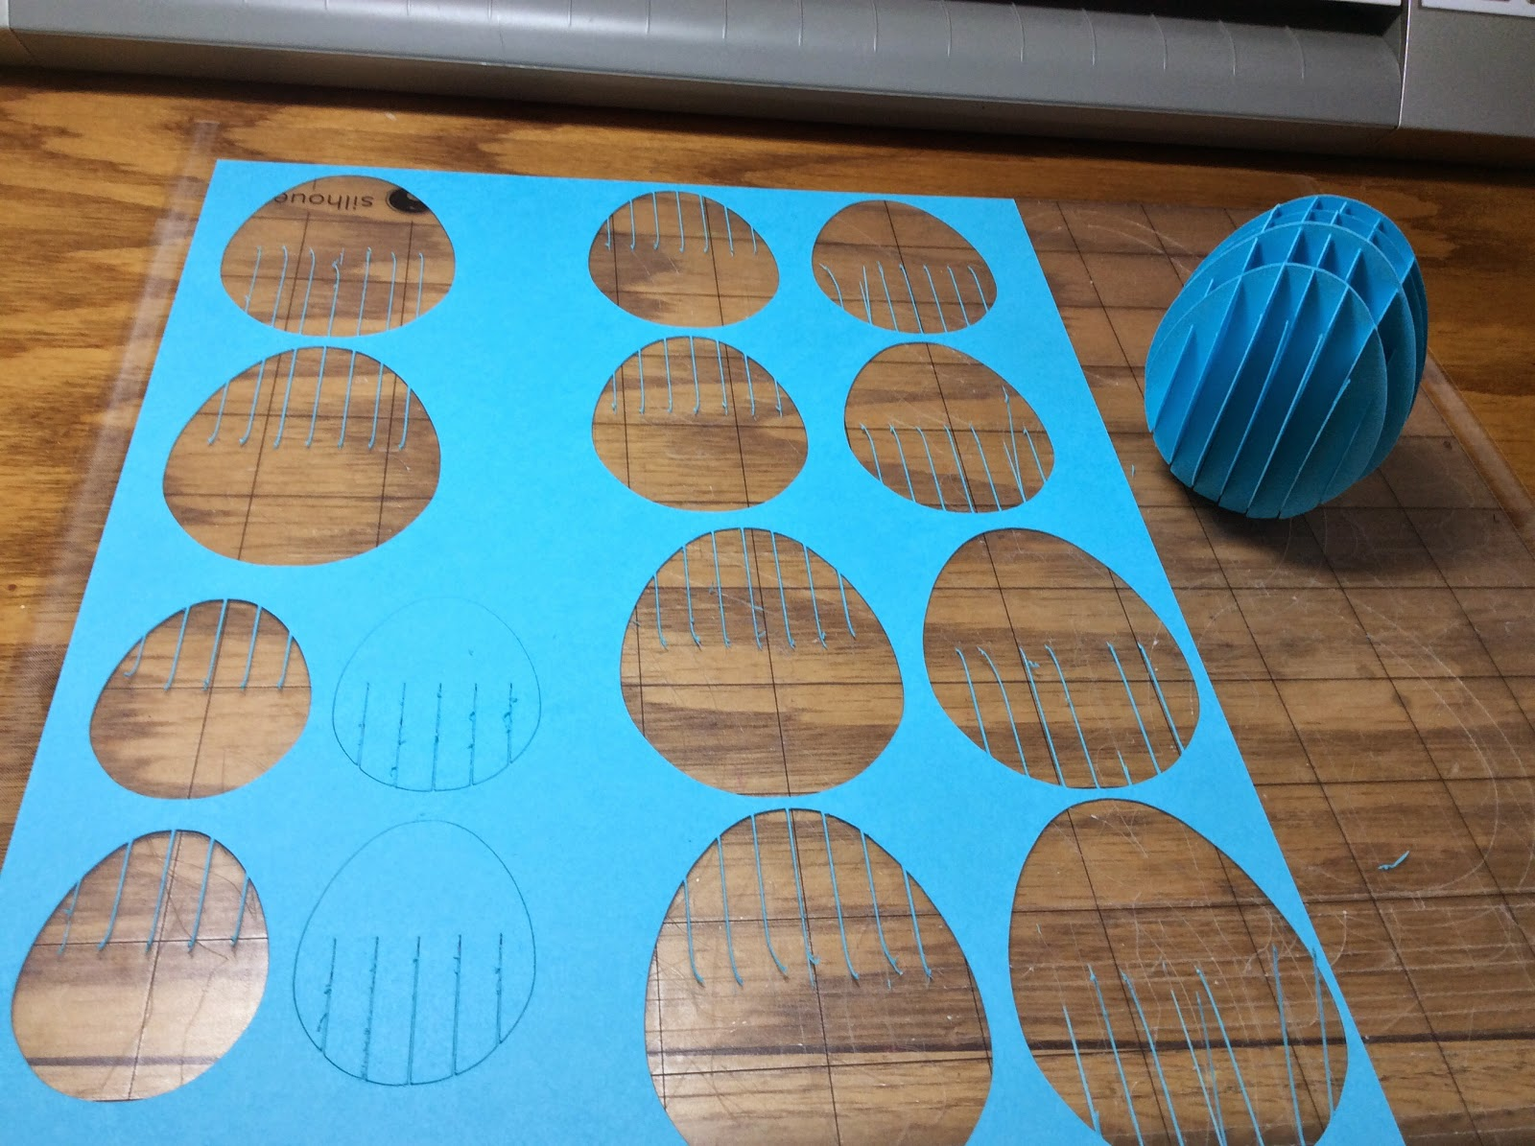

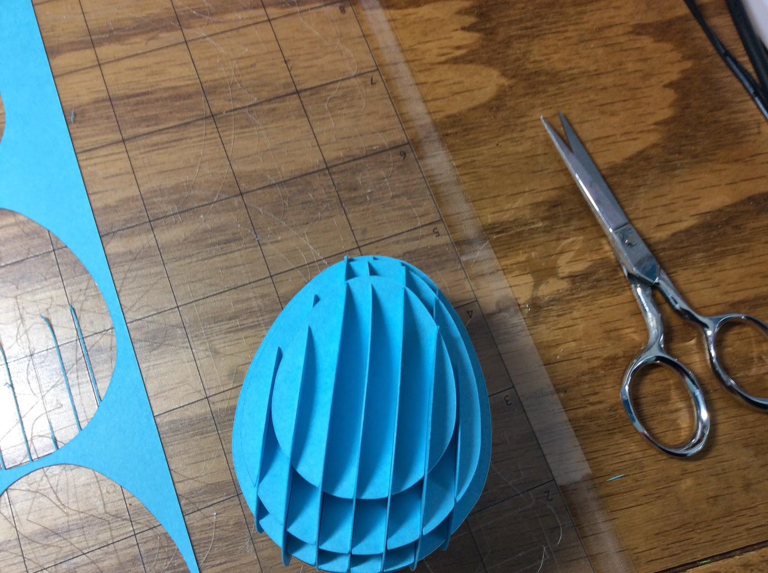

Using a glue stick, glue the bunny pieces together to create the framework for holding up the Easter egg. Make sure that you do not glue the tabs together at the bottom of the bunnies. The bunny was made with watercolor paper. I used white cardstock from Michaels originally and the paper was awful. It tore and created a mess which I could not fix. The watercolor paper cut beautifully on the Silhouette and I used the cardstock settings to cut this paper.

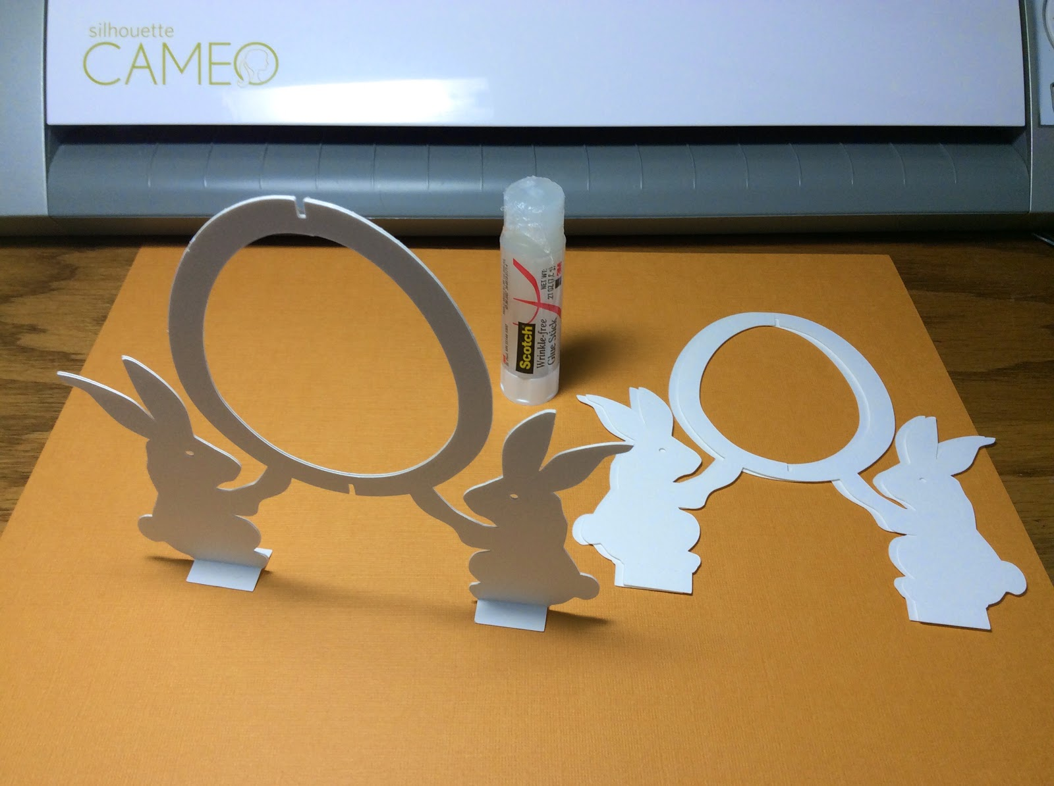

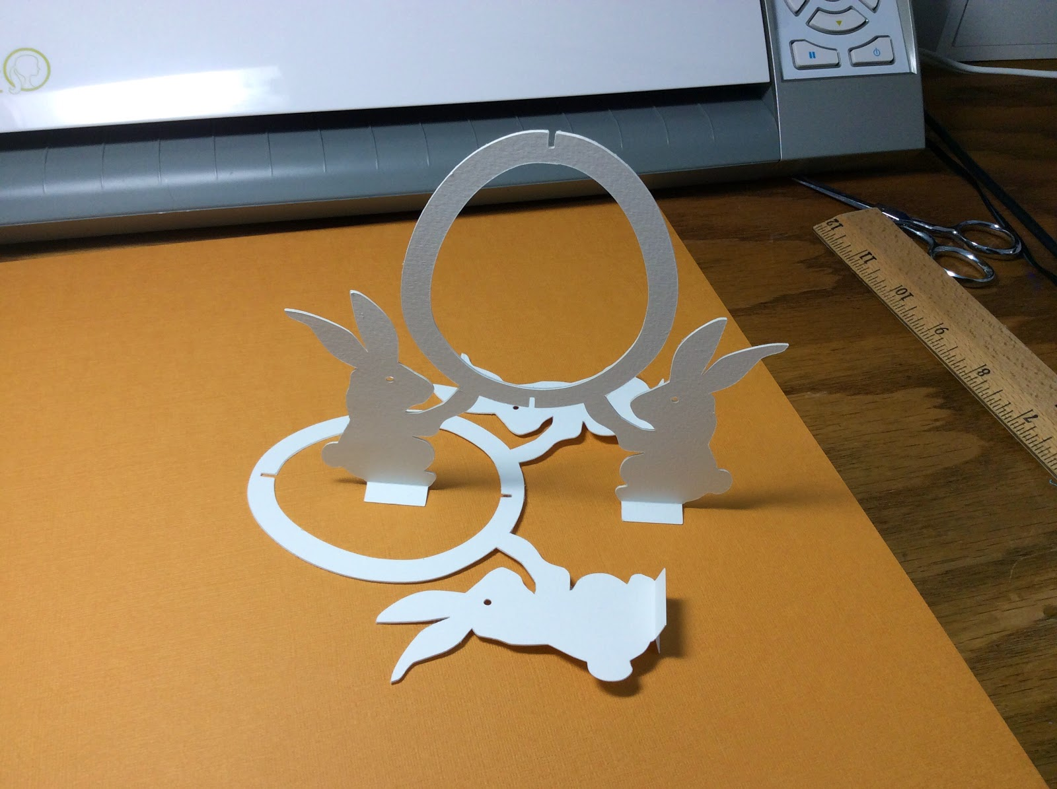

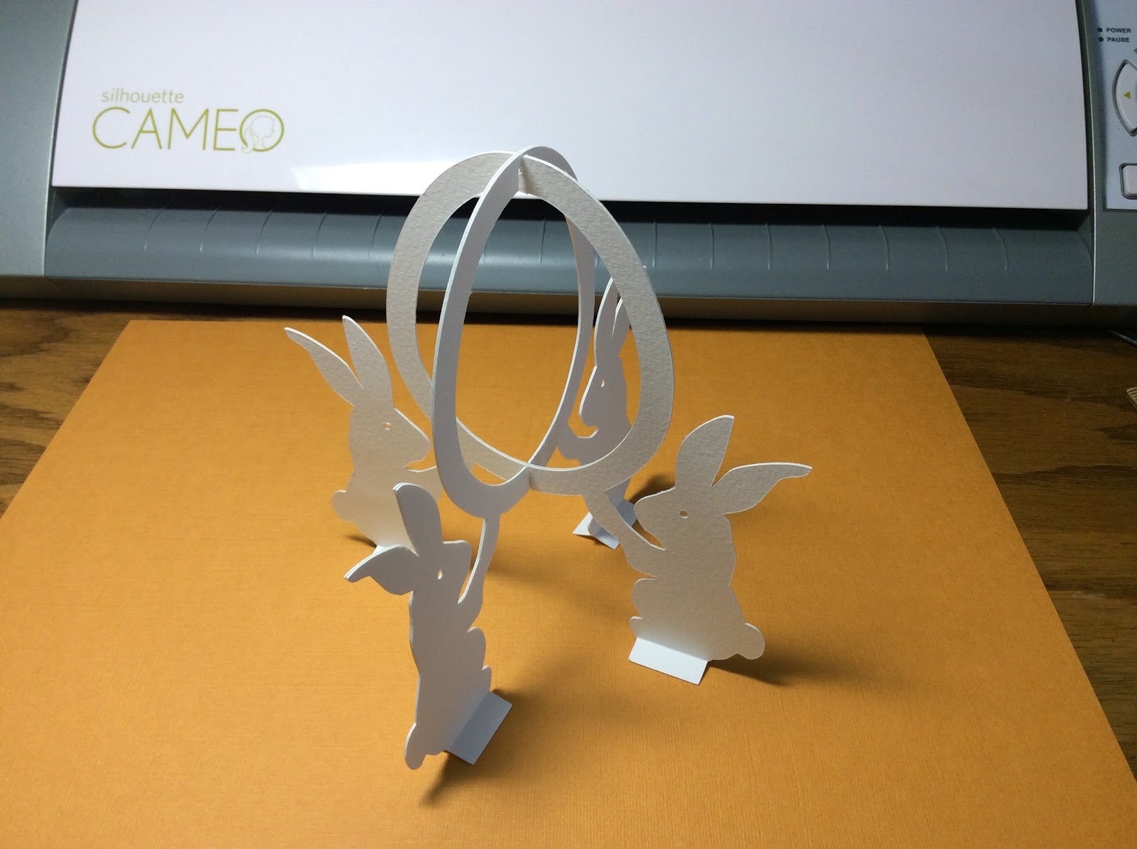

Laying the inner slit piece down, place the outer slit piece in the middle as shown. Connect the two pieces, by inserting the slits together to form the bunny structure. Add the sliceform egg to the middle by folding it flat and then expanding it once it is inside the bunny egg framework.

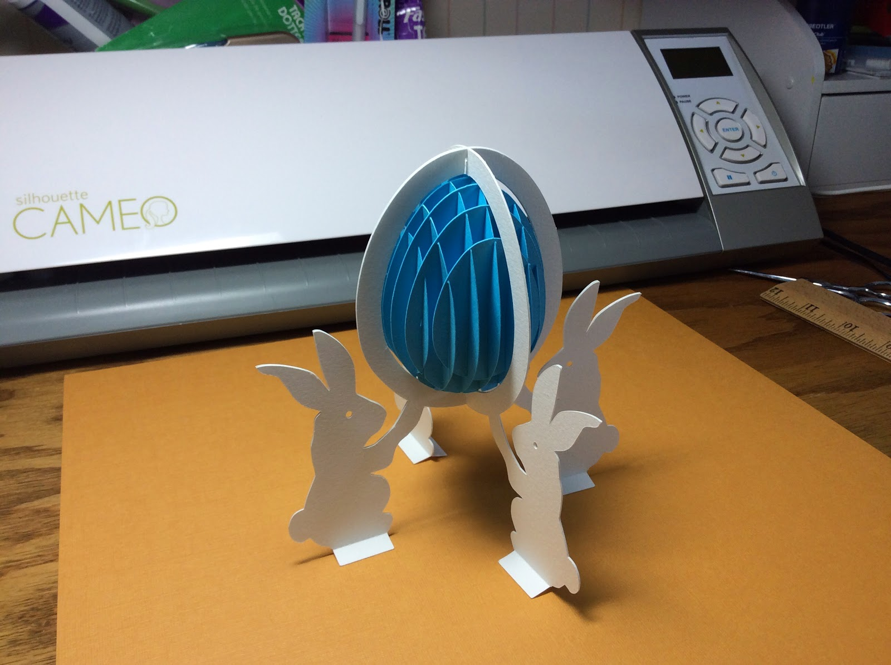

Make the box. Glue the two bottom pieces together. Fold and then glue it into a hexagon. Fold down the sides as shown in the picture. Slide the smaller inside hexagon shape into the box to form the bottom of the box. Using a glue stick, apply glue to the hexagon shape. Turn it over and add the larger hexagon to the bottom.

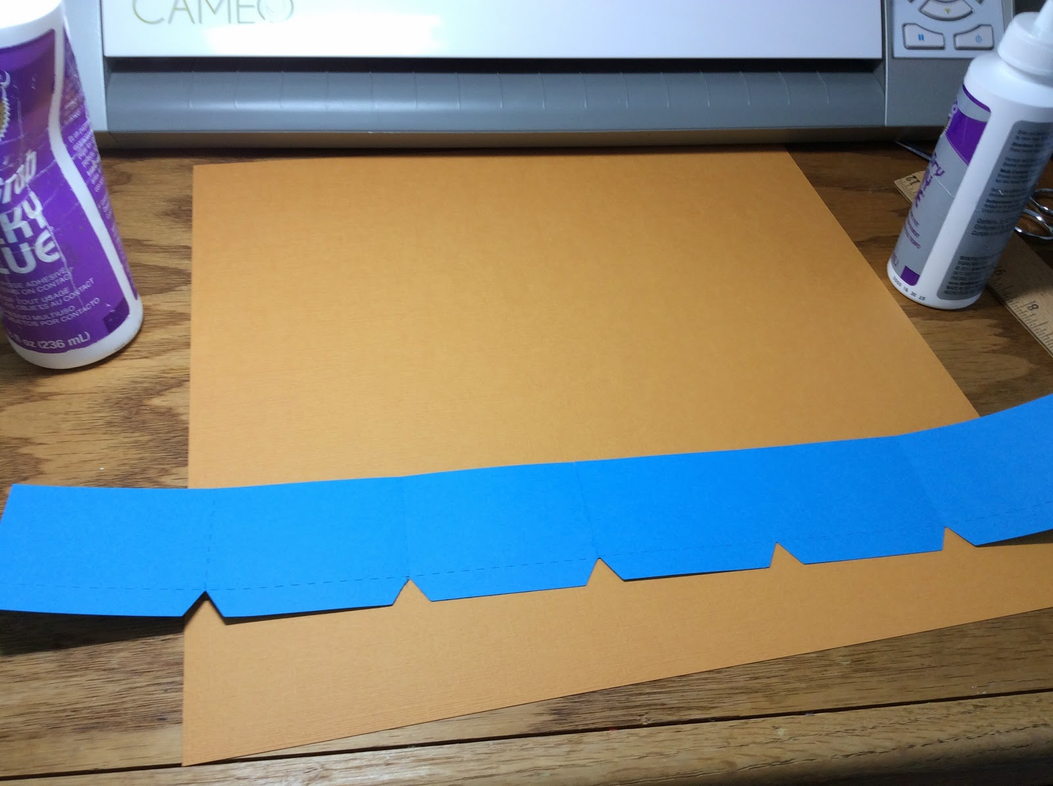

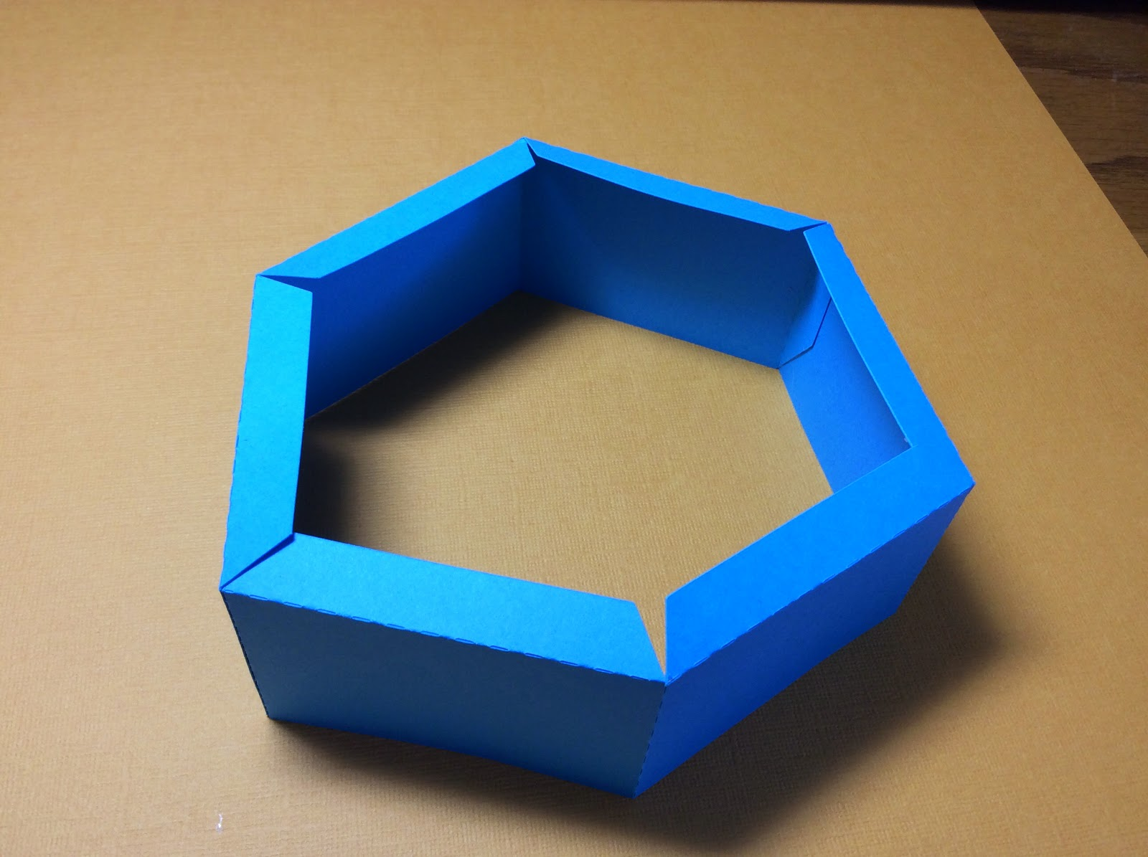

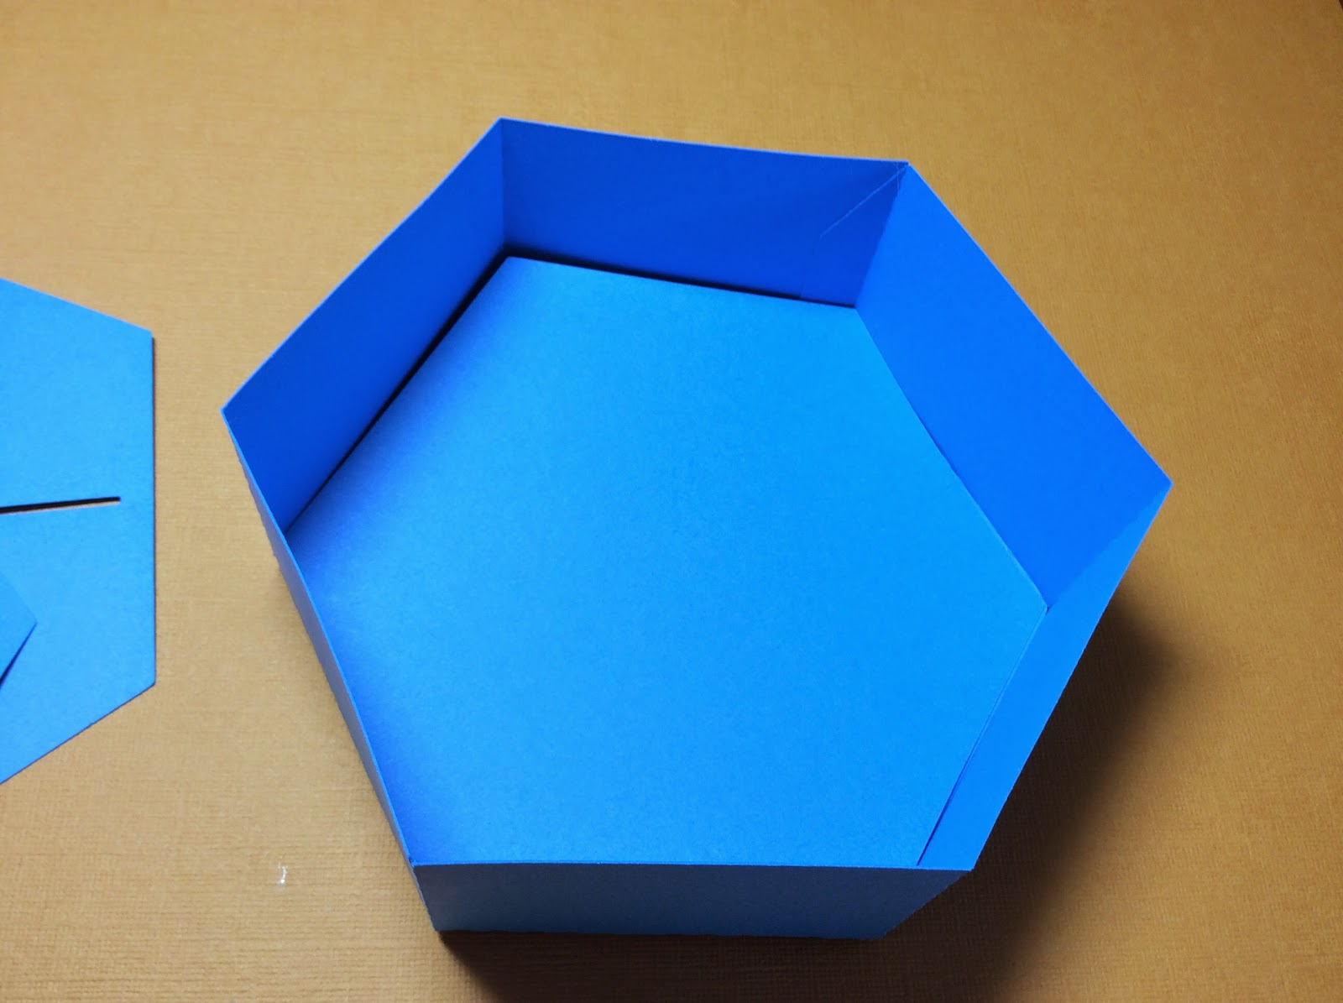

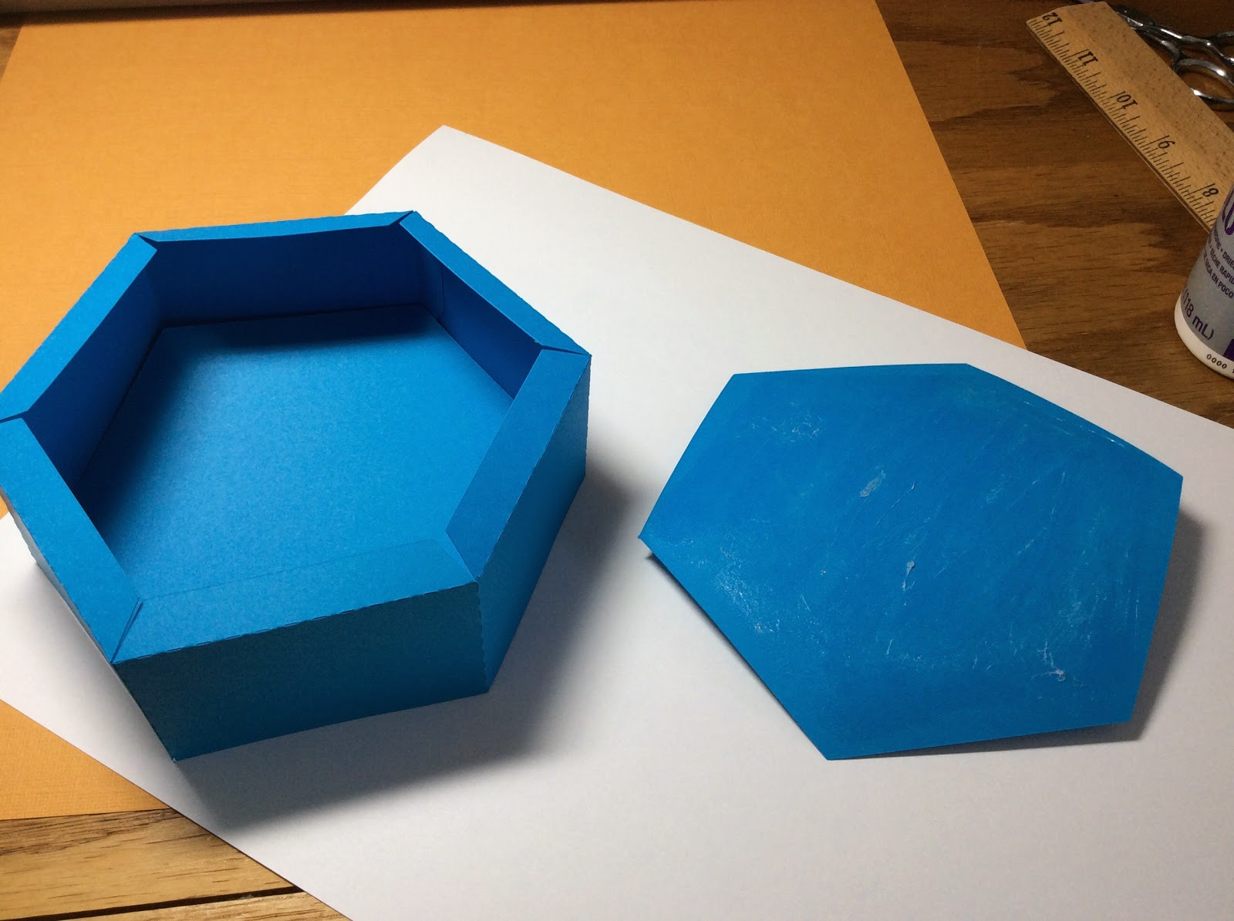

Repeat the procedure to make the top of the box using the largest scalloped pieces. Then connect the second largest pieces together and place it on top of the largest scallop. Make sure they fit together. (I did not use glue to connect these two pieces. I just slide one on top of the other.)

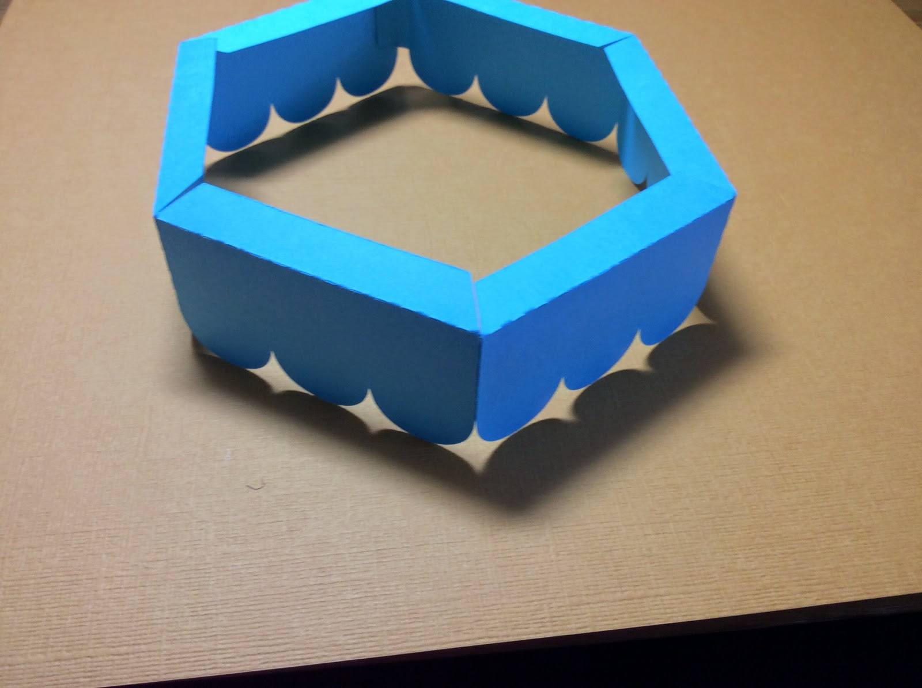

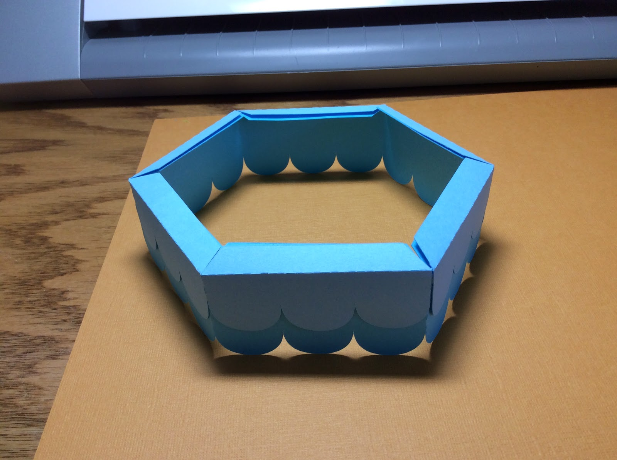

Glue the bunny structure by sliding into the slits and gluing to the top. Using a glue stick add glue to the rest of the top. Glue the other hexagon too with a glue stick. Attach together.

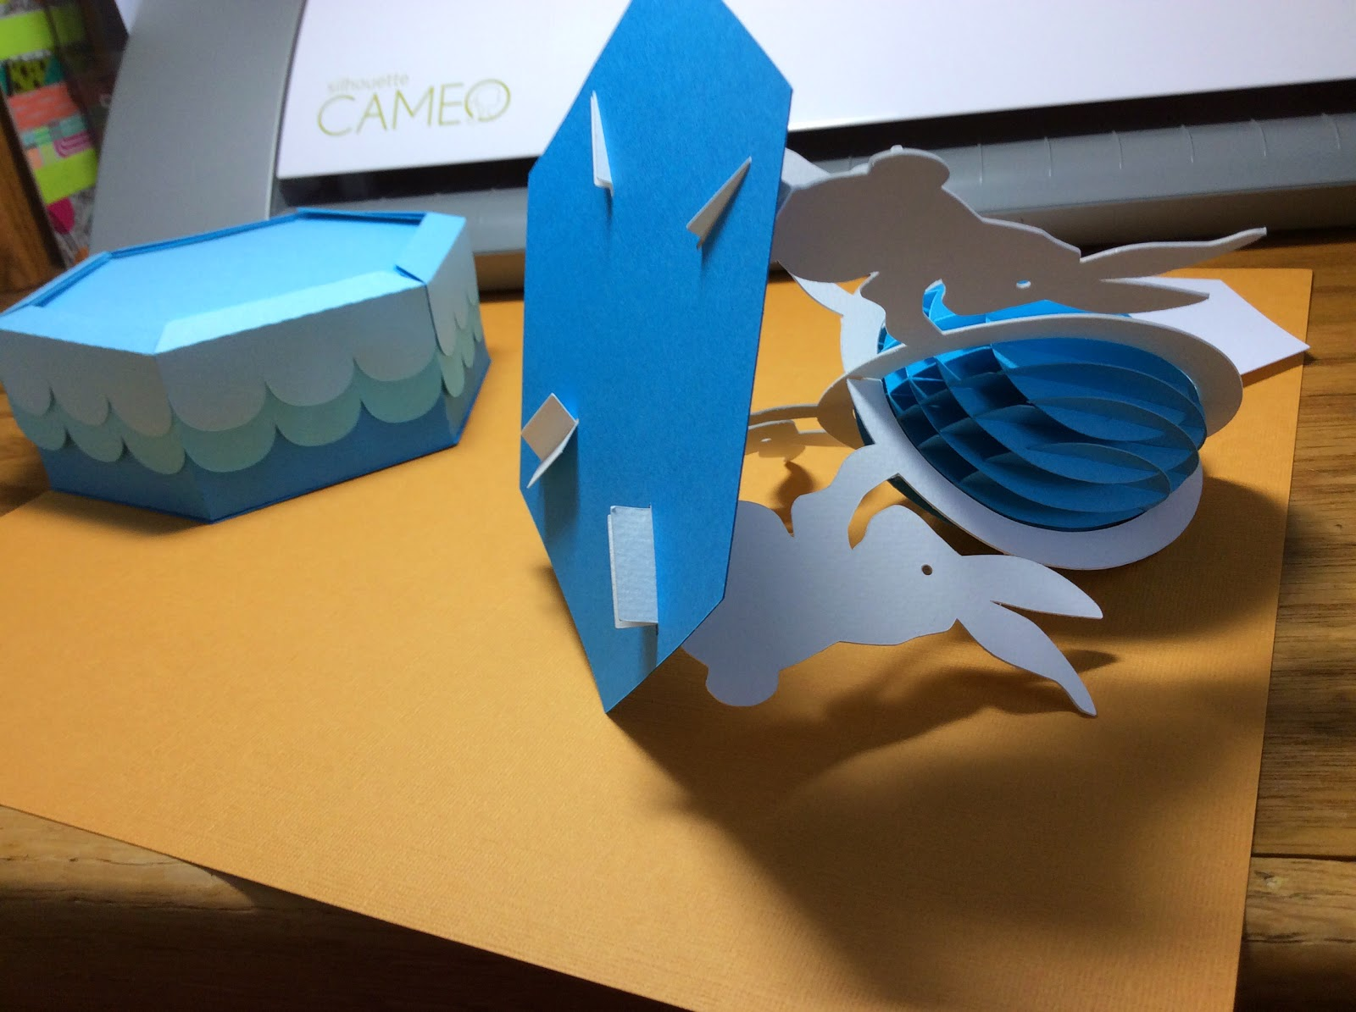

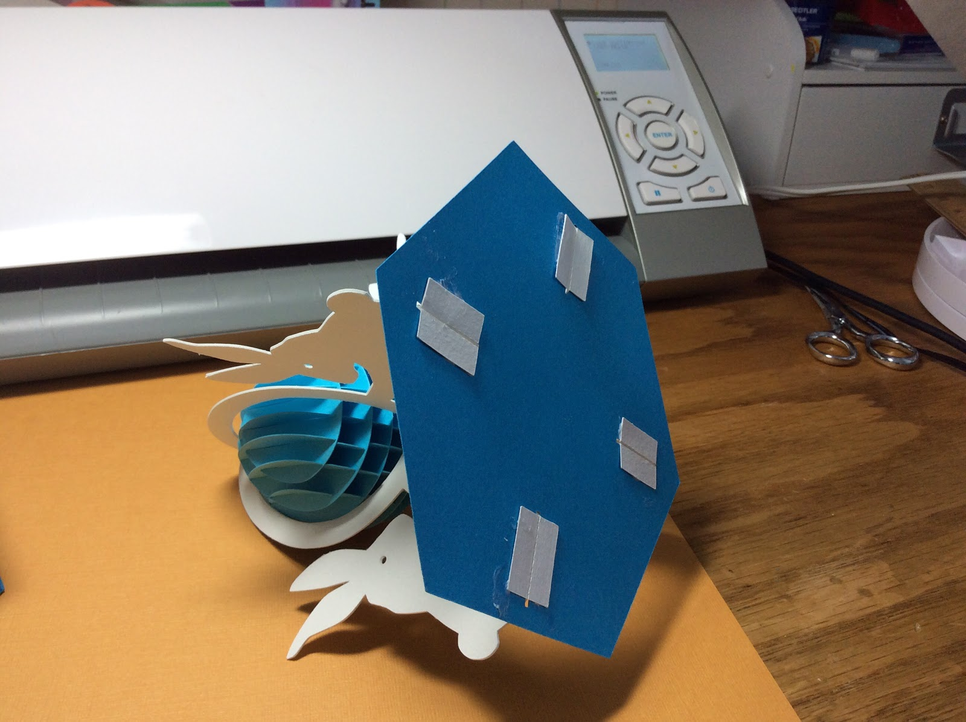

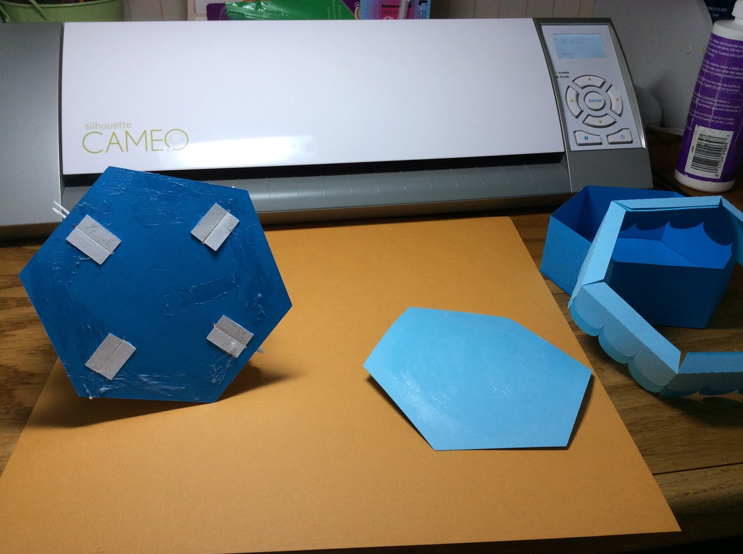

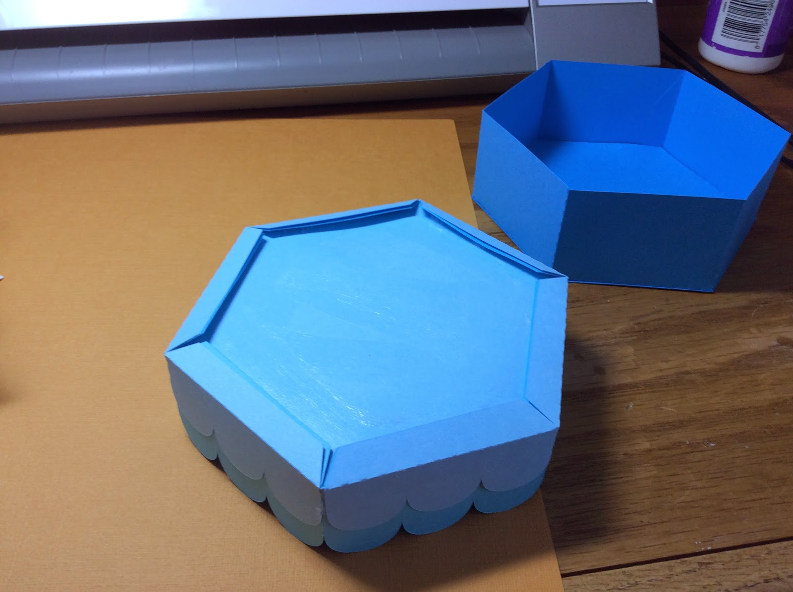

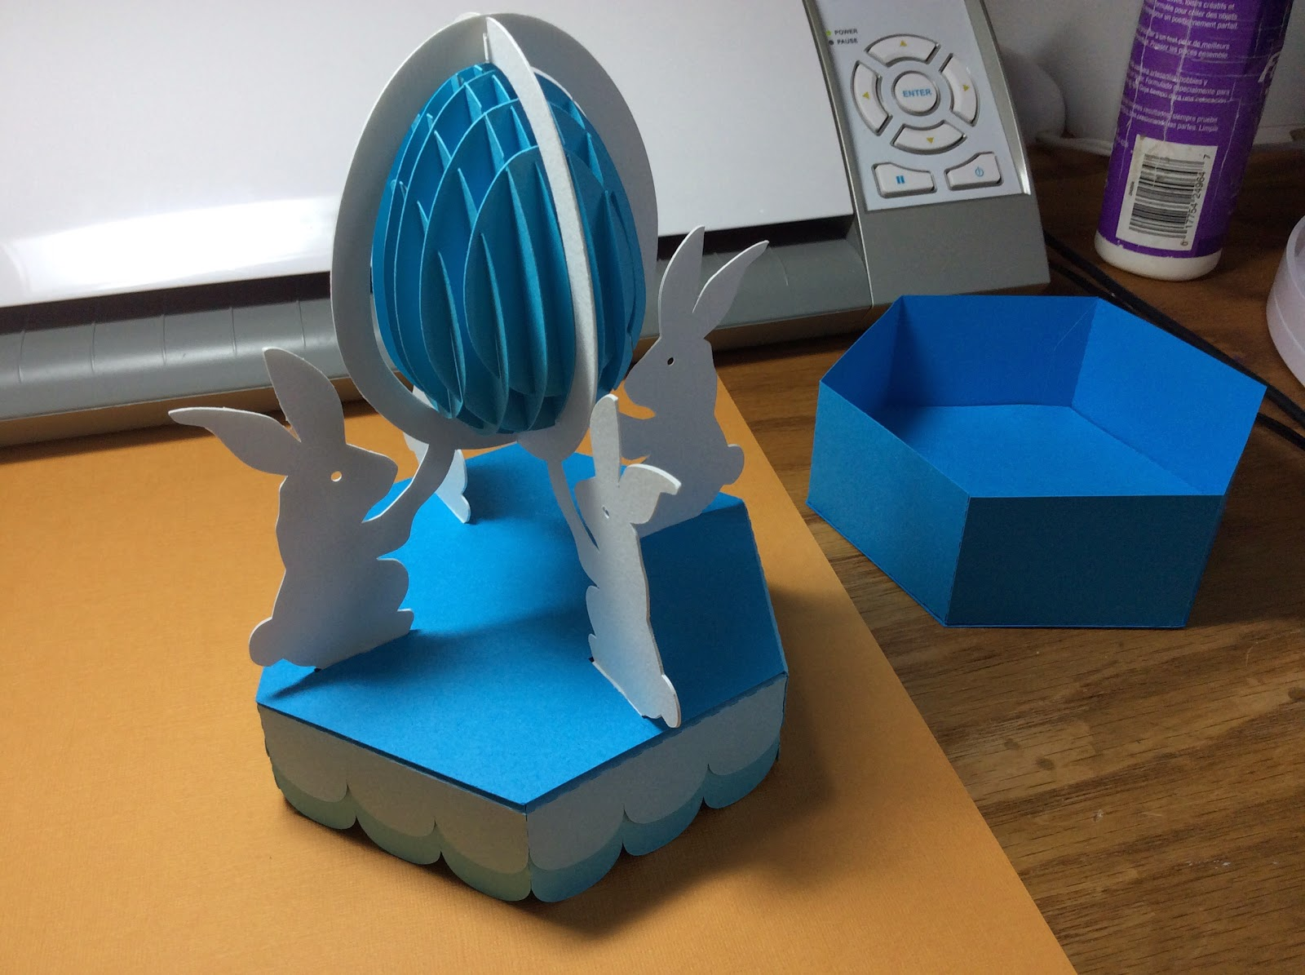

Glue the stripe to the smallest scallop piece and attach to the box.

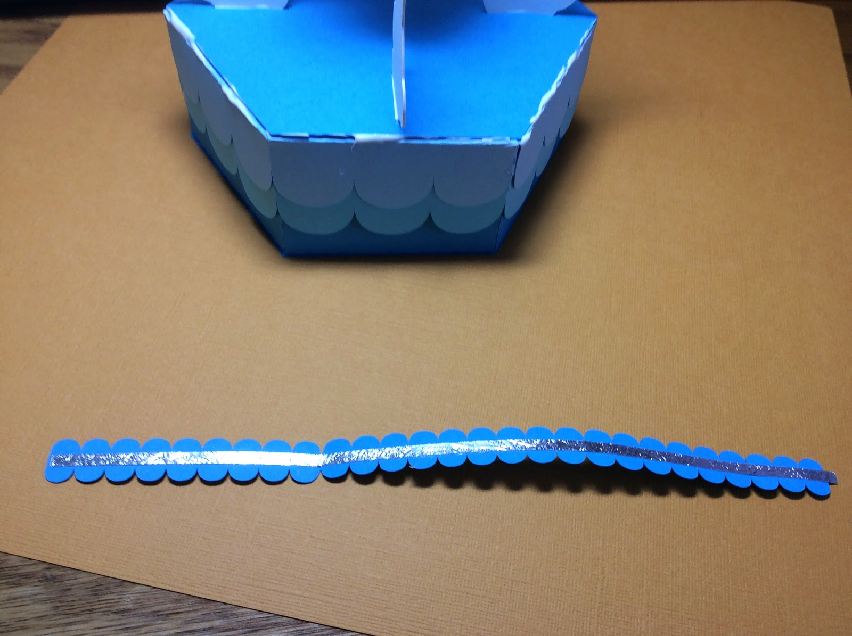

Repeat for the second scalloped piece with the stripe to encircle the entire box.

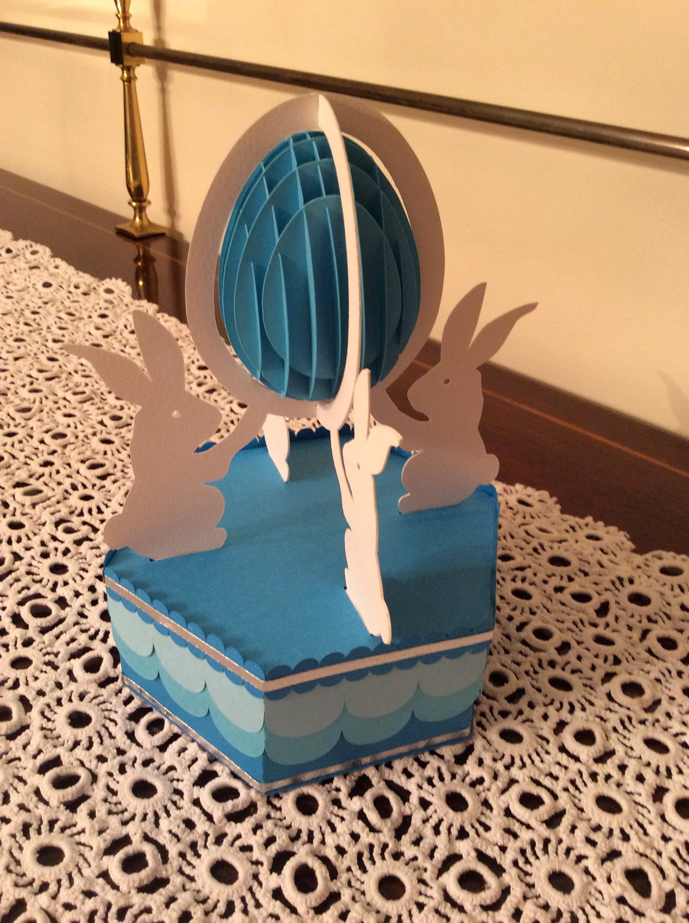

Add another stripe to the bottom of the box.